Reading Multiple Choice Steps Song:



Picture

Question ?

_________

Underline



Read



Evidence

[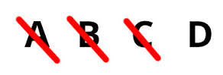](https://www.google.com/imgres?imgurl=https://blog.prepscholar.com/hs-fs/hubfs/body_800reading_answers-1.jpg?t%3D1477870187222%26width%3D365%26height%3D124%26name%3Dbody_800reading_answers-1.jpg&imgrefurl=http://blog.prepscholar.com/how-to-improve-your-act-reading-score-tips&docid=ohXjcWlbXht3JM&tbnid=0v5CEeITZvYVCM:&w=365&h=124&safe=strict&bih=710&biw=1047&ved=0ahUKEwjJlZzu1orQAhVl1oMKHZ08BJwQMwhcKDcwNw&iact=mrc&uact=8)

Eliminate



(then find the) Answer!

Prompt Writing Steps Song



Picture Walk

[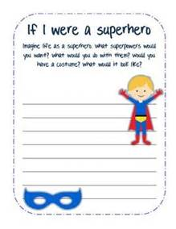](http://www.bing.com/images/search?q=read+prompt&view=detailv2&adlt=strict&id=65CF76624A14DF3EC606F5C33B6BFA03C6566E56&selectedIndex=355&ccid=10/XR6cu&simid=608049971724486346&thid=OIP.Md74fd747a72e56e24bf60be952bb10ffH0)

Read Prompt

Underline _________

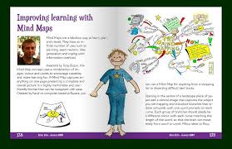

Read Text

Prewrite 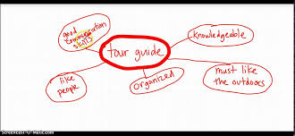

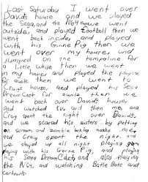

Write It!



Check the Prompt and Proofread!