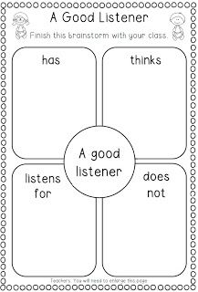
F.L.I.P.
(HINTS FOR WIDA LISTENING TESTS)
Focus – Remove any DISTRACTIONS! Distractions are things that take your attention away from what you should be doing. (Papers, noises, thoughts about life, etc.) Sit as far away from others as possible. Request a new seat if the person next to you distracts you! You have the RIGHT to take your best test possible!
Listen – Make sure your volume is just right on your headset. If it’s not, adjust it to your comfort level. Pause your test if an announcement from the P.A. system begins, or a bell is ringing, etc. REMEMBER THAT YOU CAN ONLY HEAR THE DIRECTIONS AND QUESTIONS ON A LISTENING TEST ONE TIME! YOU CAN’T GO BACK AND HEAR IT AGAIN!
Ideas – Don’t JUST listen, be an active listener! Look at the answer choices as they’re being discussed. Think about and try to UNDERSTAND as you listen. Sometimes it’s good to point at the actual picture in the screen that goes with what they are saying. It helps your brain remember details about THAT picture!
Predict – As you listen, make guesses about what you THINK the questions might be about. But don’t choose your answer too fast! Sometimes the computer talks about ALL of the pictures. WAIT for the QUESTION before you answer!

